OWNERSHIP CERTIFICATE
To Whom It May Concern

This is to certify that the following equipment listed below is the sole property of Sudhir Equipment Rental Company:

Equipment | DIESEL SOUND PROOF GENERATOR
Brand / Make | Leyland
Asset ID | SG-852-60
Model Number | VEPL-60-CDP
Serial Number | VEPL/2023-24/205
Engine Number | PHHM113528
Alternator Serial Number | G23H337132
Rating | 60 KVA
Manufacturing Year | 2023

This certification is issued to confirm the ownership status of the aforementioned equipment. Sudhir Equipment Rental Company holds full legal ownership rights over the listed equipment and retains all associated benefits and responsibilities.
Should there be any queries or requests for verification regarding the ownership of the mentioned equipment, please do not hesitate to contact us at : Info@sudhirrentals.com

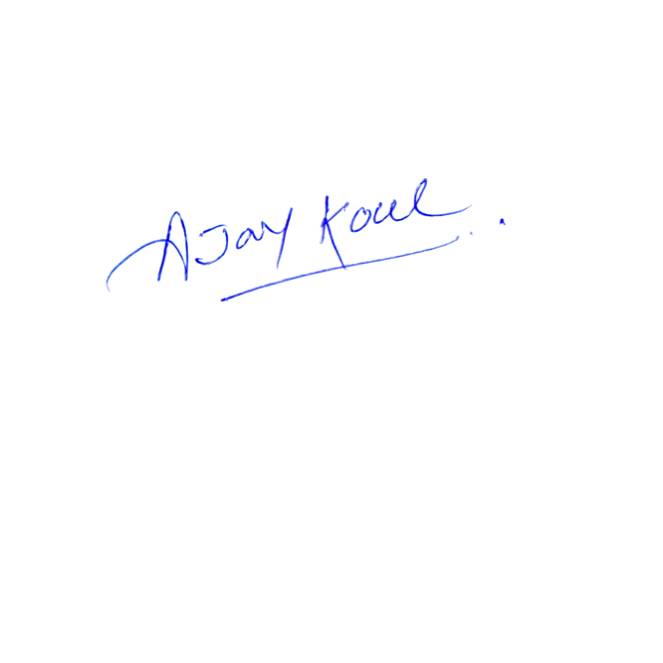
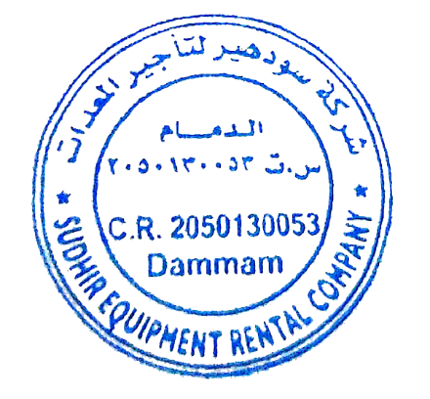
Sincerely,

Ajay Koul
General Manager
Sudhir Equipment Rental Company

